Title – Extended abstract – max. 4 pages

E-mail address: corresponding_
Abstract (max. 200 words)
Keywords:

Here introduce the main text. The paragraphs continue from here and are only separated by headings, subheadings, images and formulae. The section headings are arranged by numbers, bold and 10 pt. Here follow further instructions for authors.

  - Structure
Please make sure that you use as much as possible normal fonts in your document. To avoid unnecessary errors, you are strongly advised to use the ‘spellchecker’ function of MS Word. Follow this order when typing manuscripts: Title, Authors, Affiliations, Abstract, Keywords, Main text (including figures and tables), Acknowledgements, References.

  - Tables
All tables should be numbered with Arabic numerals. Every table should have a caption. Headings should be placed above tables. Only horizontal lines should be used within a table, to distinguish the column headings from the body of the table, and immediately above and below the table. Tables must be embedded into the text and not supplied separately. Below is an example which the authors may find useful.
Table 1. An example of a table.
An example | A | B
an entry | a | b
another entry | c | d
another entry | e | f
  - Section headings
Section headings should be left justified, bold, with the first letter capitalized and numbered consecutively, starting with the Introduction. Sub-section headings should be in capital and lower-case italic letters, numbered 1.1, 1.2, etc, and left justified, with second and subsequent lines indented. All headings should have a minimum of three text lines after them before a page or column break. Ensure the text area is not blank except for the last page.
  - General guidelines for the preparation of your text
Avoid hyphenation at the end of a line. Symbols denoting vectors and matrices should be indicated in bold type. Scalar variable names should normally be expressed using italics. Weights and measures should be expressed in SI units. All non-standard abbreviations or symbols must be defined when first mentioned, or a glossary provided.

- Illustrations
All figures should be numbered with Arabic numerals (1,2,3,….). Every figure should have a caption. All photographs, schemas, graphs and diagrams are to be referred to as figures. The figure number and caption should be typed below the illustration in 8 pt and centered.
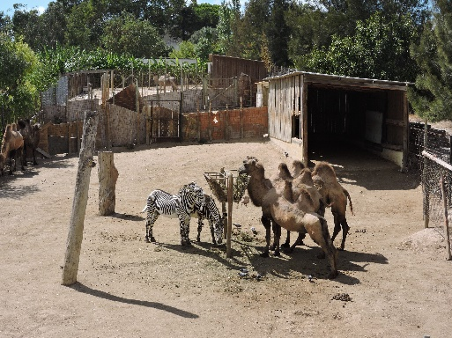
Figure 1: example
- Equations
Equations and formulae should be typed in Mathtype, and numbered consecutively with Arabic numerals in parentheses on the right hand side of the page (if referred to explicitly in the text). They should also be separated from the surrounding text by one space.
Acknowledgements
Acknowledgements and References heading should be left justified. References appear with numbers.
References
[1] Clark, T., Woodley, R., De Halas, D., 1962. Gas-Graphite Systems, in “Nuclear Graphite”. In: Nightingale, R. (Ed.). Academic Press,
New York, pp. 387.
[2] Fachinger, J., den Exter, M., Grambow, B., Holgerson, S., Landesmann, C., Titov, M., Podruhzina, T., 2004. Behavior of spent HTR fuel elements in aquatic phases of repository host rock formations, 2nd International Topical Meeting on High Temperature Reactor Technology. Beijing, China, paper #B08.
[3] Deep-Burn Project: Annual Report for 2009, Idaho National Laboratory, Sept. 2009.

